Suppl 6. Sensitivity analysis

(a) Sensitivity analysis excluding abstracts for RGC
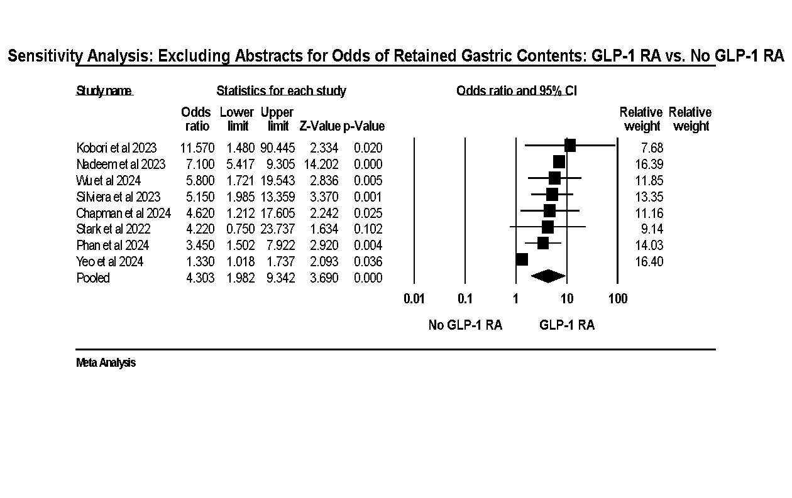

(b) Sensitivity analysis excluding one study for RGC
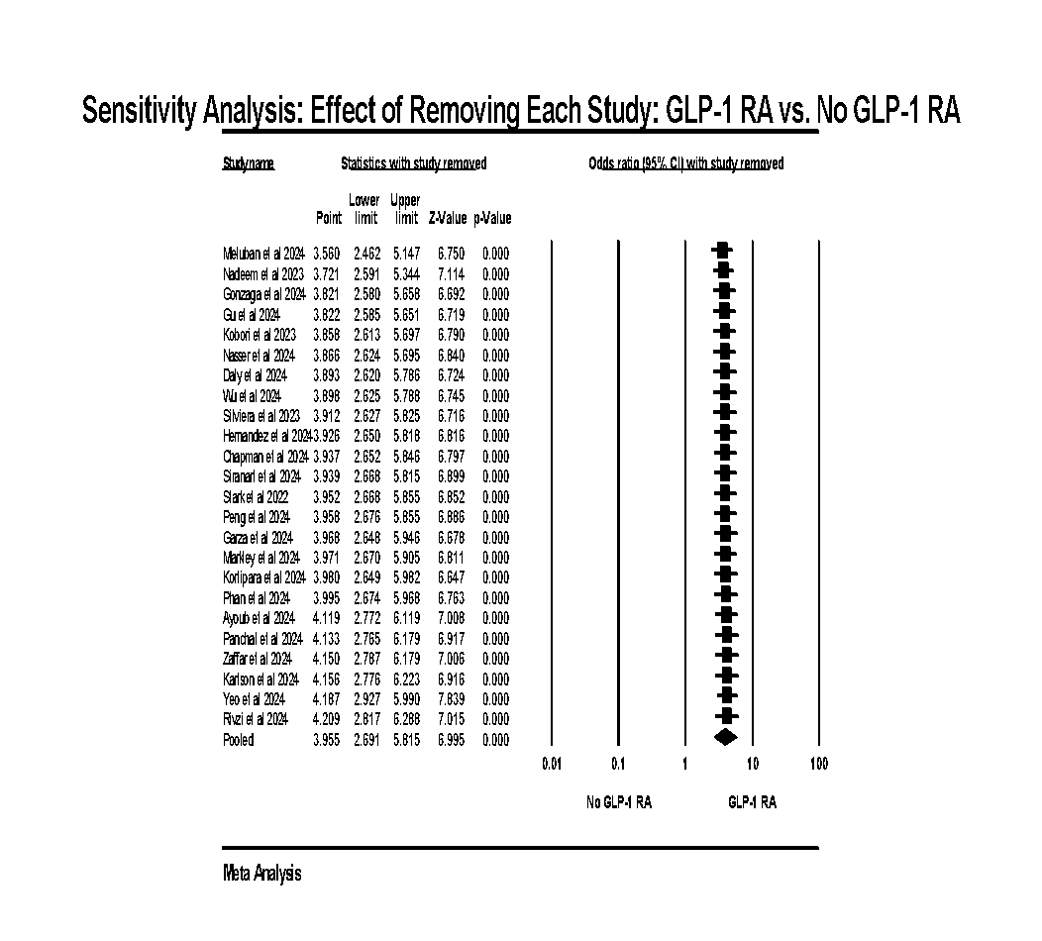

(c) Sensitivity analysis excluding one study for cancelled procedure
