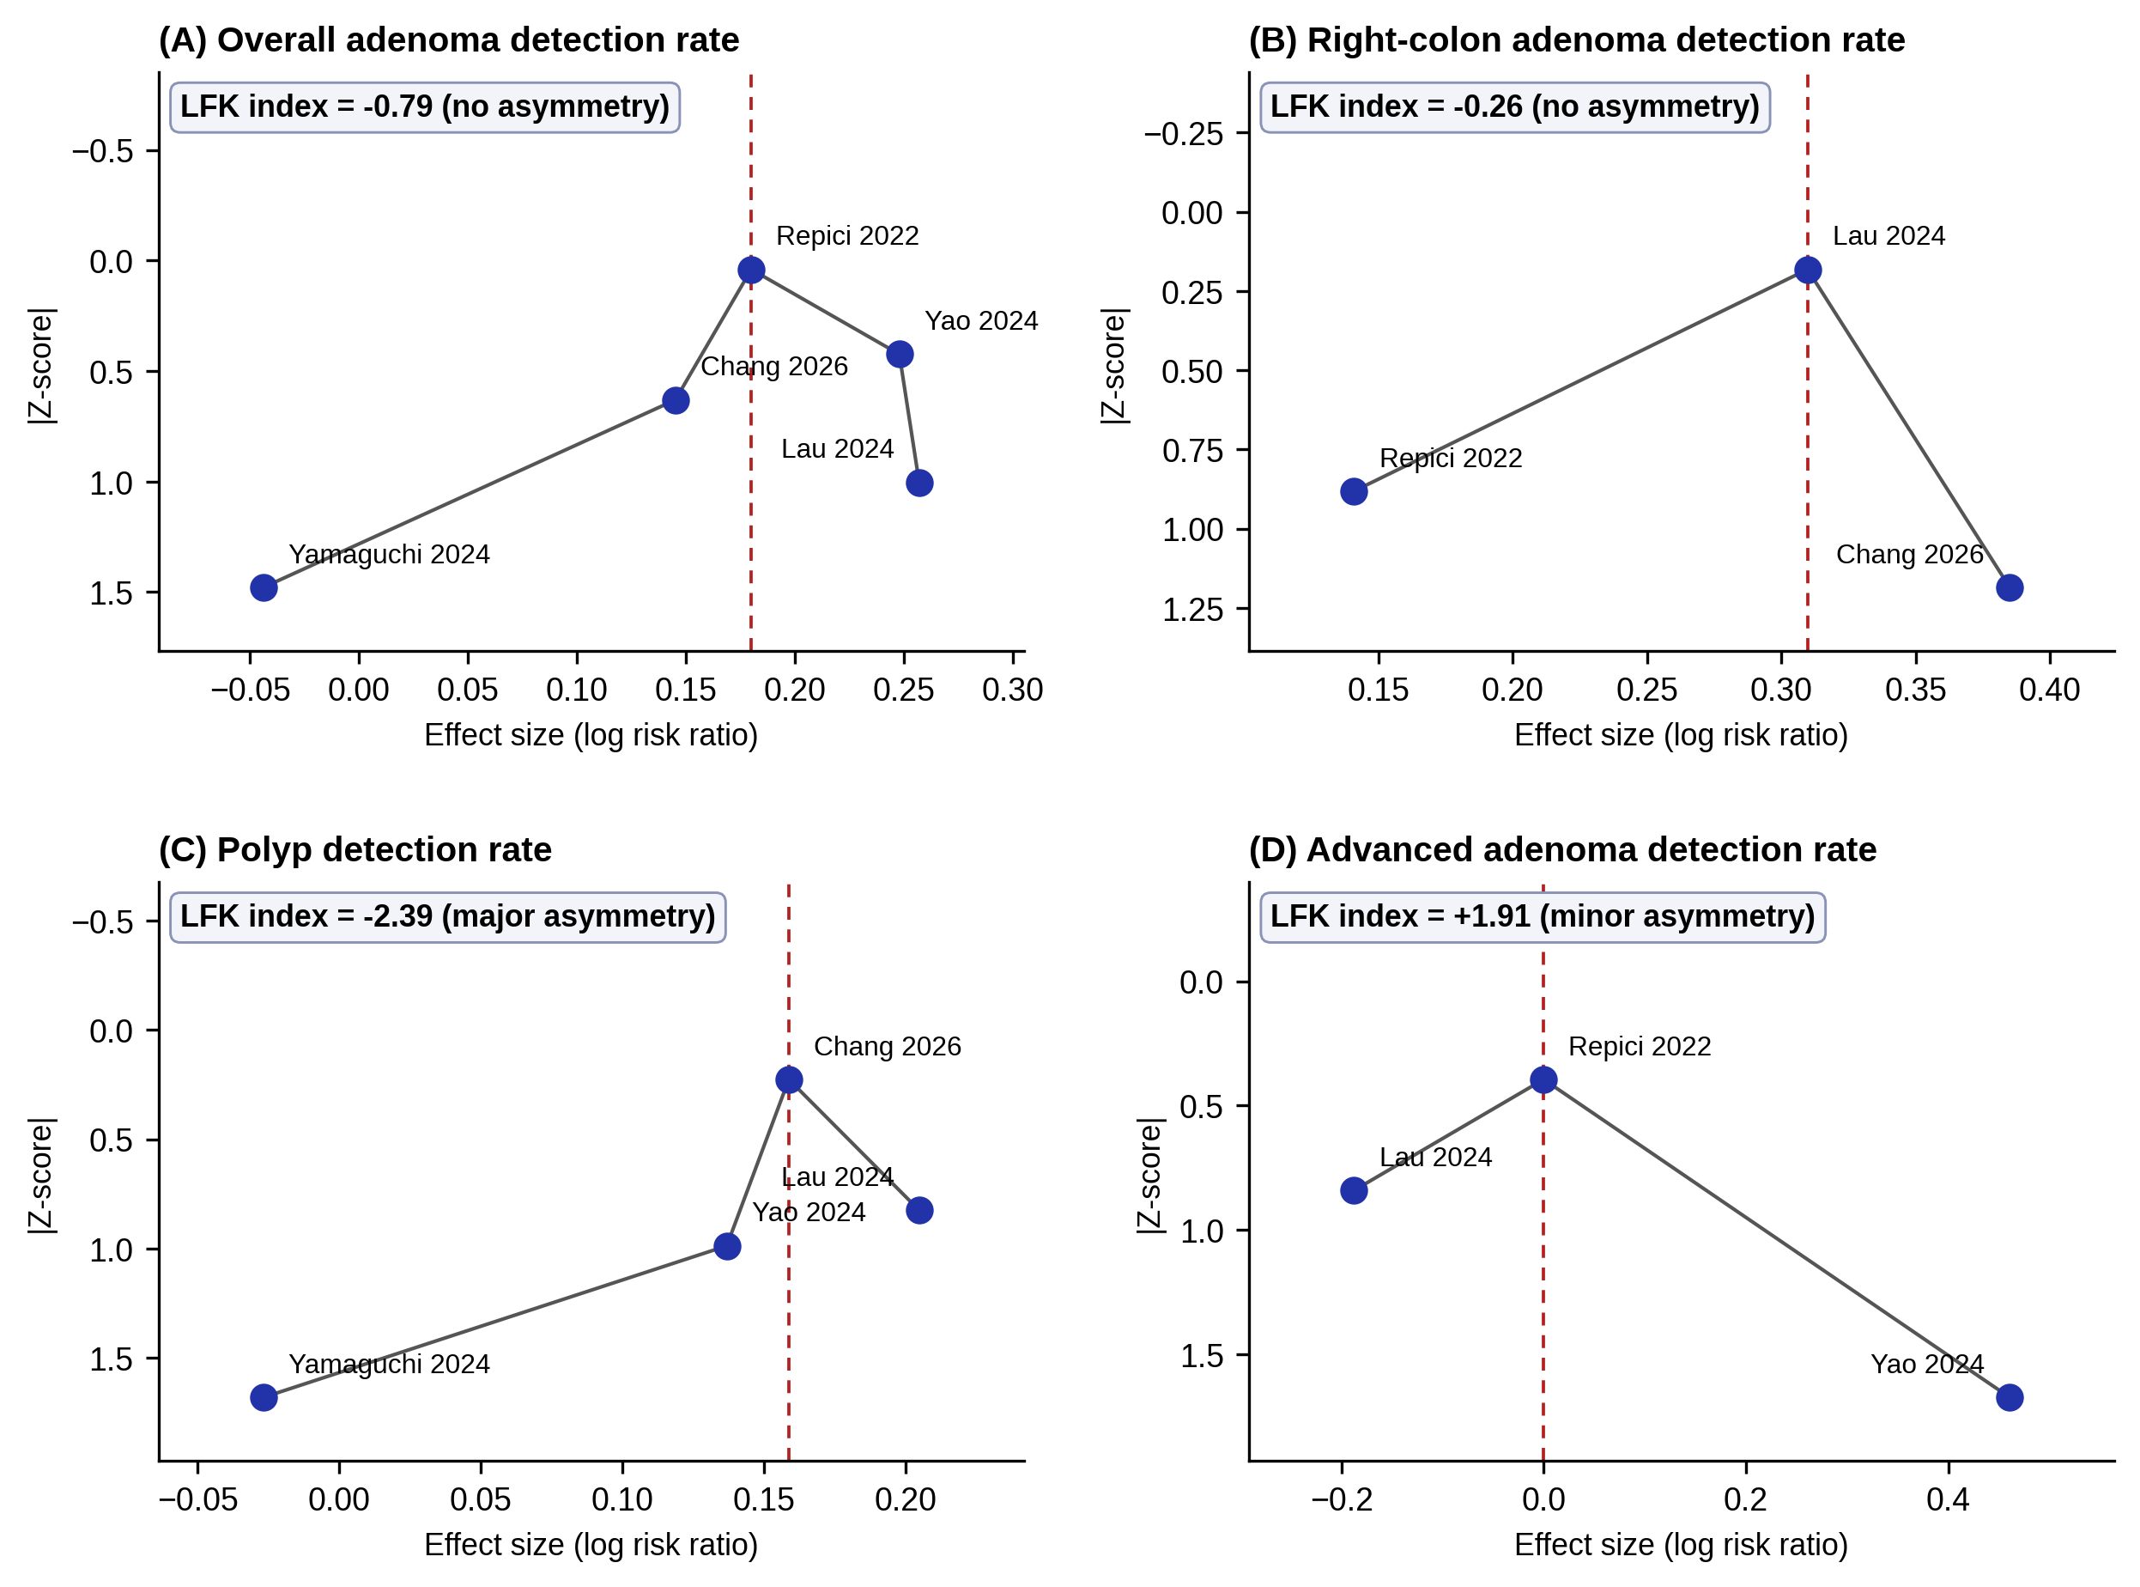
Suppl7. Doi plots with the Luis Furuya-Kanamori (LFK) index. (A) Overall adenoma detection rate. (B) Right-colon adenoma detection rate. (C) Polyp detection rate. (D) Advanced adenoma detection rate. Effect size is plotted against the absolute Z-score, with the vertical axis inverted so that the study nearest the pooled estimate appears at the top. An LFK index within ±1 indicates no asymmetry, ±1 to ±2 minor asymmetry and beyond ±2 major asymmetry. With only three to five contributing trials per outcome these indices are exploratory and are not a reliable basis for inferring publication bias. LFK, Luis Furuya-Kanamori index.

