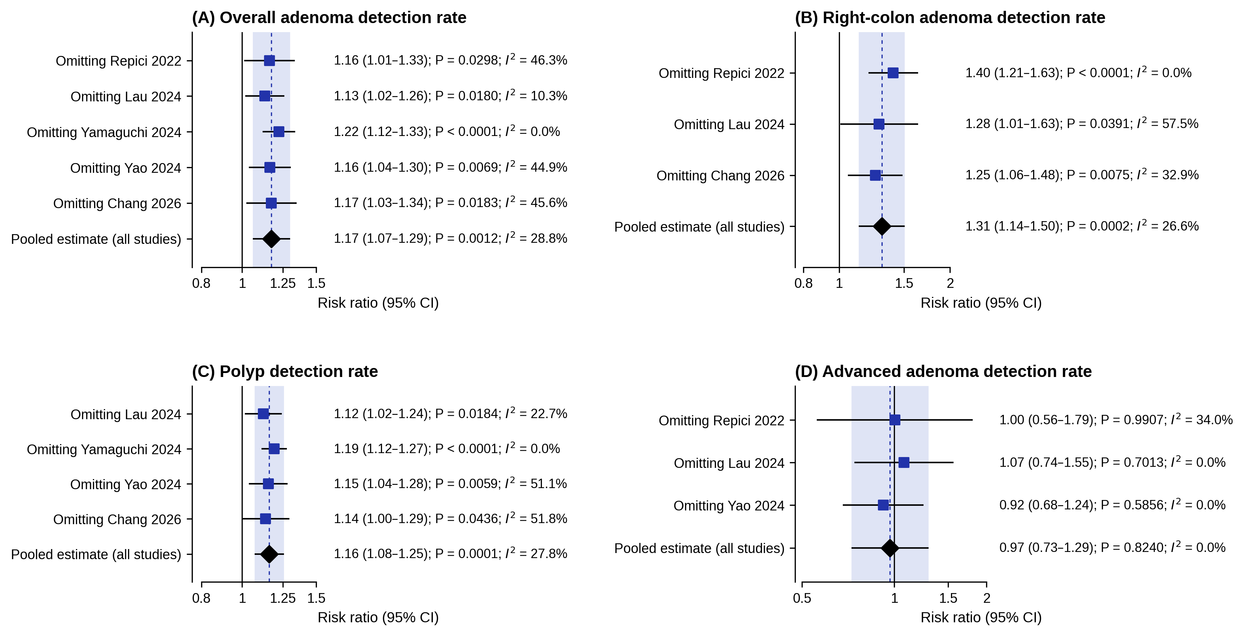
Suppl5. Leave-one-out sensitivity analyses. (A) Overall adenoma detection rate. (B) Right-colon adenoma detection rate. (C) Polyp detection rate. (D) Advanced adenoma detection rate. Within each panel, every row shows the pooled risk ratio recalculated with the named trial omitted; the bottom row is the pooled estimate from all contributing trials. The shaded band and the vertical dashed line show the confidence interval and the point estimate of the full analysis. CI, confidence interval; I², I-squared statistic for heterogeneity; RR, risk ratio.

