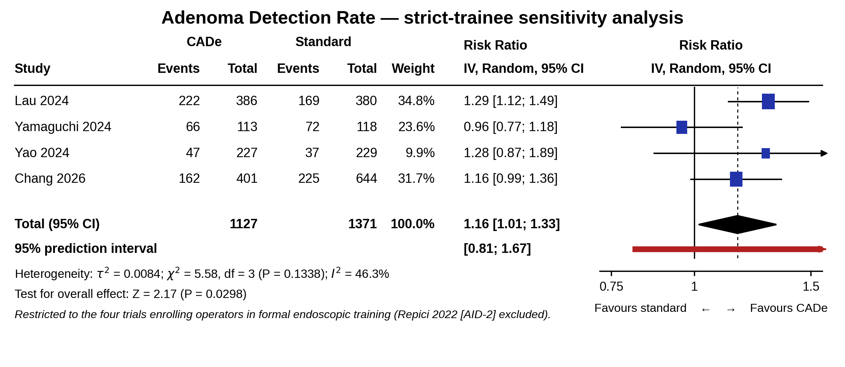
Suppl6. Forest plot for overall adenoma detection rate restricted to the four trials whose operators were enrolled in formal endoscopic training (Repici 2022 [AID-2] excluded). CADe, computer-aided detection; CI, confidence interval; I², I-squared statistic for heterogeneity; PI, prediction interval; RR, risk ratio.

